**GOOGLE AI-ML VIRTUAL INTERNSHIP**

*An Industry Oriented Internships report submitted in partial fulfilment of requirements for the award of degree of*

**BACHELOR OF TECHNOLOGY**

**IN**

**COMPUTER SCIENCE AND ENGINEERING**

**(ARTIFICIAL INTELLIGENCE AND MACHINE LEARNING)**

**BY**

**ISLAVATH RAGHUNAIK 322103382018**

**N SANJEEV REDDY 322103382042**

**V RAKESH KUMAR 322103382050**

**TARAKANTA ACHARYA 322103382058**

**Under the esteemed guidance of**

**Internship Mentor Name of Course Coordinator**

**Dr. R. Seetha Sireesha Dr. Ch. Sitha Kumari**

**(Associate Professor) (Associate Professor)**

**Department of Computer Science and Engineering**

**GAYATRI VIDYA PARISHAD COLLEGE OF ENGINEERING(AUTONOMOUS)**

(Affiliated to Andhra University, Visakhapatnam)

**VISAKHAPATNAM**

**2023-24**

**GAYATRI VIDYA PARISHAD COLLEGE OF ENGINEERING(Autonomous)**

Visakhapatnam

**CERTIFICATE**

THIS REPORT IS BASED ON

**GOOGLE AI-ML VIRTUAL INTERNSHIP**

is a bonafide record of the Internship work submitted

By

**ISLAVATH RAGHUNAIK 322103382018**

**N SANJEEV REDDY 322103382042**

**V RAKESH KUMAR 322103382050**

**TARAKANTA ACHARYA 322103382058**

In their V semester in partial fulfilment of the requirements for the Award of Degree of

**Bachelor of Technology in**

**Computer science and Engineering**

During the academic year 2023-24

**Name of the Coordinator Head of the Department**

**Dr. Ch. Sitha Kumari Dr. Uma Devi**

**Associate Professor Associate Head of CSE(AI&ML)**

**Internship Mentor**

**Dr. R. Seetha Sireesha**

**Associate Professor**

**ACKNOWLEDGMENT**

We would like to express our deep sense of gratitude to our esteemed institute **Gayatri Vidya Parishad College of Engineering (Autonomous)**, which has provided us an opportunity to fulfill our cherished desire.

We express our sincere thanks to our Principal **Dr. A.B. KOTESWARA RAO, Gayatri Vidya Parishad College of Engineering (Autonomous)** for his encouragement to us during this project, giving us a chance to explore and learn new technologies in the form of mini projects.

We thank our **Internship mentor Dr. R. Sitha Sireesha,** Associate Professor, Department of Computer Science and Engineering and our **Course Coordinator Dr. Ch. Sitha Kumari,** Associate Professor and Associate head of B.Tech CSE(AI&ML) for the kind suggestions and guidance for the successful completion of our internship.

We are highly indebted to **Dr. D. Uma Devi, Associate Professor and Head of the Department of Computer Science and Engineering (AI-ML), Gayatri Vidya Parishad College of Engineering (Autonomous),** for giving us an opportunity to do the Internship in college.

We are grateful for **EDUSKILLS, GOOGLE and AICTE** for providing us this learning opportunity

Finally, we are indebted to the teaching and non-teaching staff of the Computer Science and Engineering Department for all their support in completion of our project.

**ISLAVATH RAGHUNAIK 322103382018**

**N SANJEEV REDDY 322103382042**

**V RAKESH KUMAR 322103382050**

**TARAKANTA ACHARYA 322103382058**

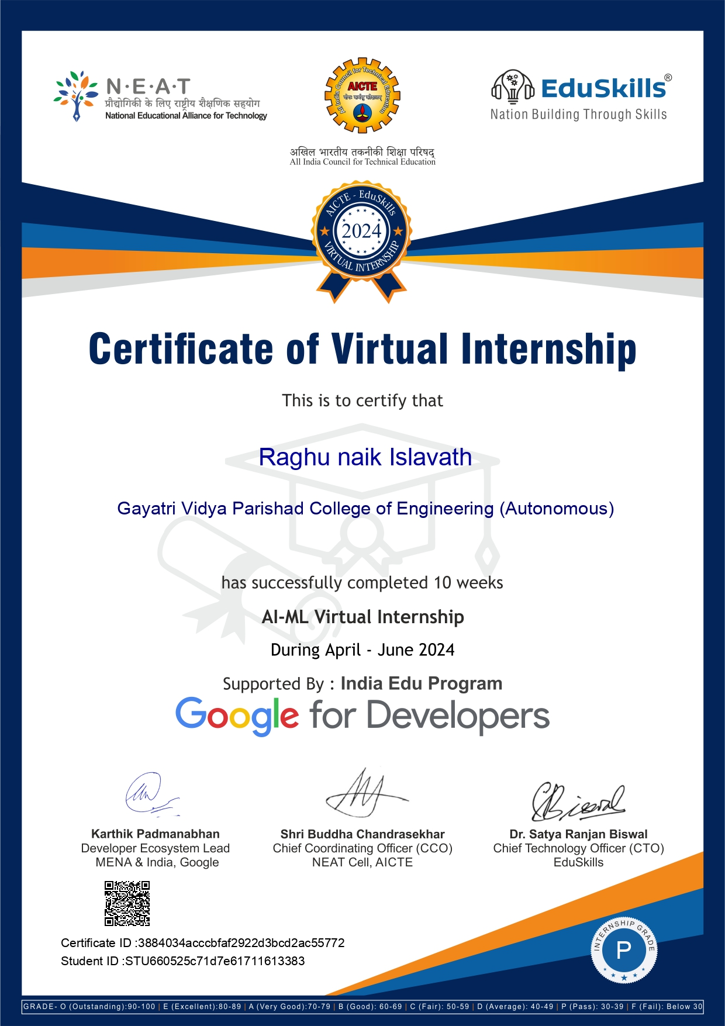

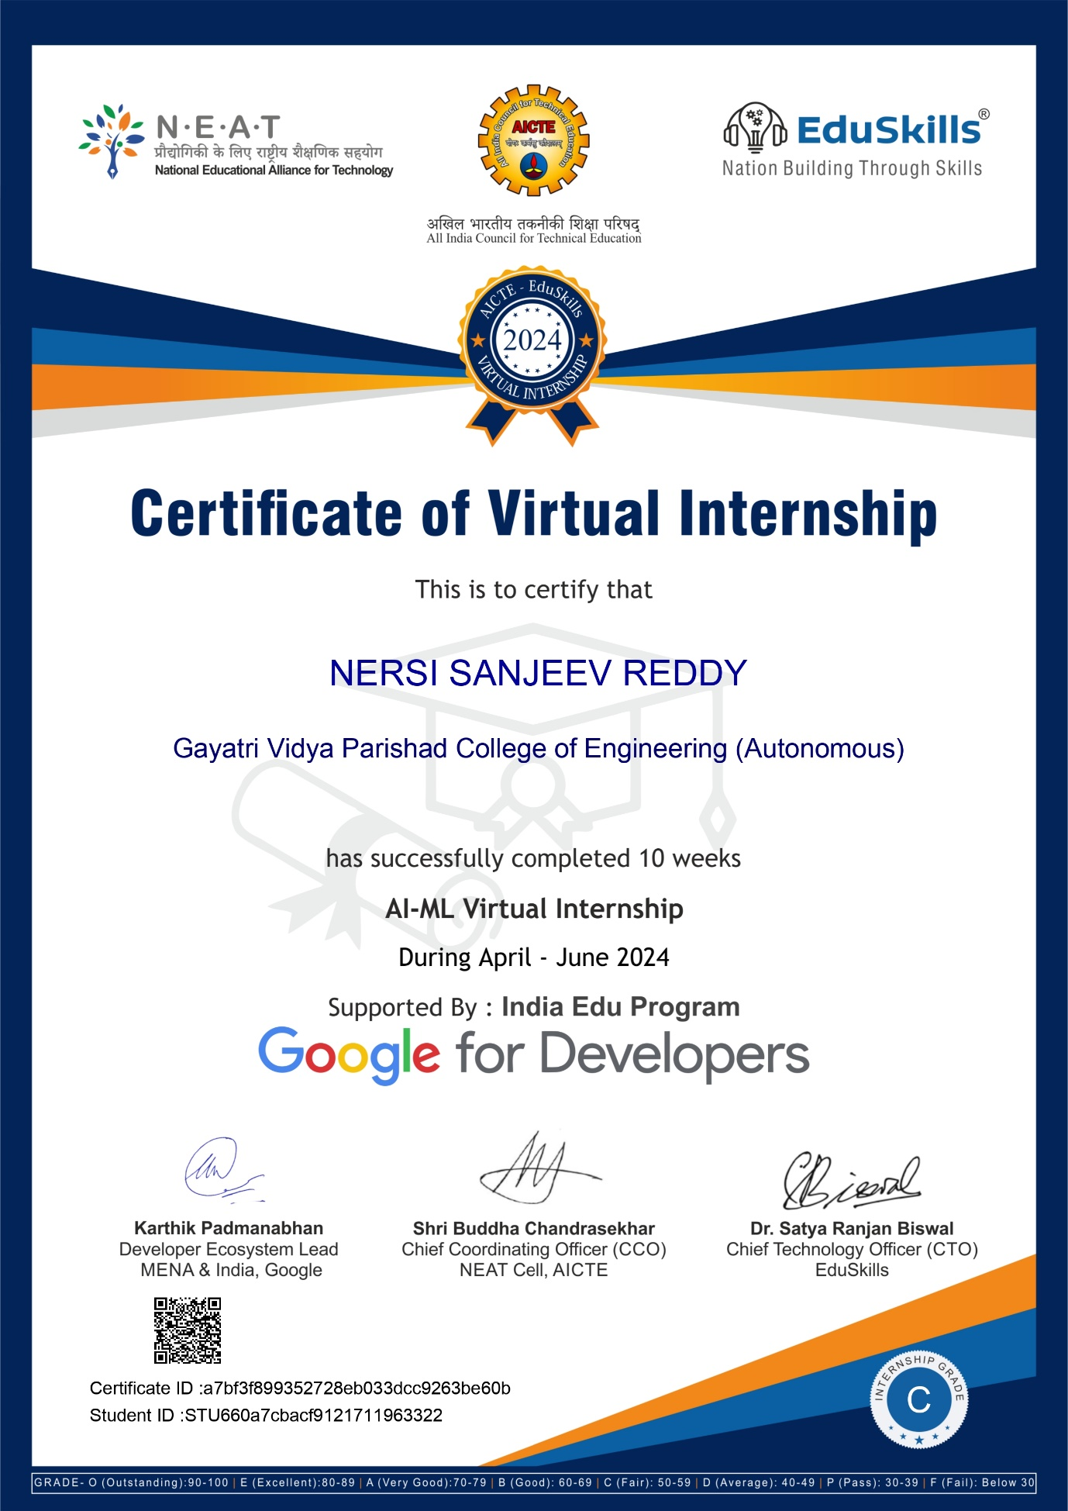



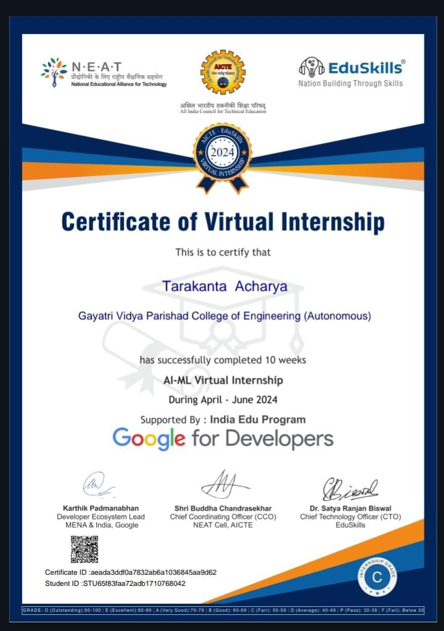

**ABSTRACT**

TensorFlow, an open-source machine learning framework by Google, simplifies the development and deployment of machine learning models. Convolutional Neural Networks (CNNs) are extensively used for image tasks, utilizing convolutions to extract important features and pooling to reduce feature map dimensionality. Object detection, a significant CNN application, involves identifying and locating objects in images. Implementing this in Android Studio with TensorFlow Lite allows real-time, efficient mobile processing, enhancing user experience with smart, on-device AI capabilities through data collection, preprocessing, model training, and integration.

Product image search and image classification are pivotal applications of Convolutional Neural Networks (CNNs) in the retail and e-commerce sectors. By utilizing convolutions to extract distinctive features from images and pooling to manage data complexity, these technologies enable efficient identification and categorization of products. Product image search allows users to find similar items by uploading a photo, enhancing the shopping experience. Image classification categorizes products into predefined classes, streamlining inventory management and improving search accuracy. Implementing these applications with TensorFlow Lite in mobile environments ensures real-time, on-device processing, providing users with responsive and intelligent AI-driven solutions.

The increasing demand for accurate and rapid medical diagnostics has prompted the development of automated tools to aid healthcare professionals. This case study focuses on an X-ray image classifier designed to differentiate between COVID-19, pneumonia, and normal lung conditions using Convolutional Neural Networks (CNNs). Integrated into a Flask web application, the classifier provides a user-friendly platform for uploading and analyzing X-ray images, with NGrok enabling remote access for seamless demonstrations and testing from any location.

The results demonstrate the classifier's high accuracy in distinguishing between various lung conditions, highlighting its potential as a reliable diagnostic tool. Detailed analysis of the results provides insights into the model's strengths and areas for improvement, ensuring its practical application in real-world scenarios. The integration into a web application enhances accessibility for healthcare professionals, improving diagnostic accuracy and efficiency.

**INDEX**

**MODULE-1: Program neural networks with TensorFlow 1**

* 1. **Introduction…………………………………………….……1**
  2. **Machine Learning……………………………………….…..2**
  3. **Design a Machine Learning model…………………….…...3**
  4. **Convolution and Pooling……………………………….…...4**

**MODULE-2: Get Started with Object Detection 7**

* 1. **An Introduction to Object Detection……………….……....7**
  2. **Build an Object Detector into Mobile App………….……..8**
  3. **Integrate the Object Detector using ML Kit API…….……9**

**MODULE-3: Go Further with Object Detection 13**

* 1. **Training the model………………………………….………13**
  2. **Deploying the model in Android Studio………….………..14**
  3. **Setting Up and Running Object Detection on an App……15**
  4. **Display Detection Results on Image……………………….17**

**MODULE-4: Get Started with Product Image Search 18**

* 1. **Introduction…………………………………………………18**
  2. **Build an Object Detector in your Mobile App…………….18**
  3. **Detect Objects in Images to build a Visual Product ……...19**

**Search**

**MODULE-5: Get Further with Product Image Search 20**

* 1. **Call the Product search backend from the Mobile app…..20**
  2. **Build a Visual product Search Backend using Vision**

**API Product Search…………………………………………22**

**MODULE-4: Get Started with Image Classification 23**

* 1. **Introduction to Image Classifcation……………………….23**
  2. **Steps to create a custom image classifier………………….24**
  3. **Integrating the model into App…………………………….26**

**Case Study…………………………………………………………………….30**

**Conclusion…………………………………………………………………….36**

**References……………………………………………………………………..37**

**PROGRAM NEURAL NETWORKS WITH TENSORFLOW**

**MODULE 1**

**1.1 Introduction:**

TensorFlow, developed by Google, is a powerful open-source machine learning framework widely used for building, training, and deploying machine learning and deep learning models. Its comprehensive suite of tools and libraries allows developers to create complex neural networks with ease, facilitating tasks ranging from image and speech recognition to natural language processing and predictive analytics. With high-level abstractions and robust support for deployment on various platforms, including mobile and web, TensorFlow enables efficient experimentation and implementation of AI solutions in real-world scenarios. Its extensive documentation and active community further enhance its accessibility and usability, making it a popular choice among researchers and practitioners in the field of artificial intelligence.



Fig 1.1: Tensorflow badget [[11]](https://www.tensorflow.org/)

Advantages of TensorFlow:

1.Scalability: Easily scales from running on a single device to distributed computing across multiple machines and GPUs.

2.Flexibility: Supports various levels of abstraction, from high-level Keras APIs to low-level operations for custom ML models.

3.Cross-Platform Deployment: Enables deployment on multiple platforms, including mobile (TensorFlow Lite) and web (TensorFlow.js).

Applications of TensorFlow:

1.Computer Vision: Used for image classification, object detection, and image segmentation tasks.

2.Natural Language Processing (NLP): Facilitates text classification, sentiment analysis, and language translation.

3.Reinforcement Learning: Powers the development of algorithms where agents learn optimal behaviors through environment interactions.

**1.2 Machine Learning:**

Machine Learning (ML) is a branch of artificial intelligence that involves the development of algorithms and statistical models that enable computers to learn from and make predictions or decisions based on data. Unlike traditional programming, where explicit instructions are coded, ML algorithms identify patterns and relationships within data, improving their performance over time as they are exposed to more data. This technology powers a wide range of applications, from recommendation systems and image recognition to autonomous vehicles and natural language processing.[[12]](https://developers.google.com/learn/pathways/tensorflow#codelab-https://developers.google.com/codelabs/tensorflow-2-computervision)

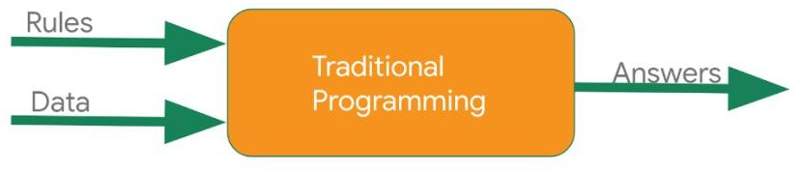

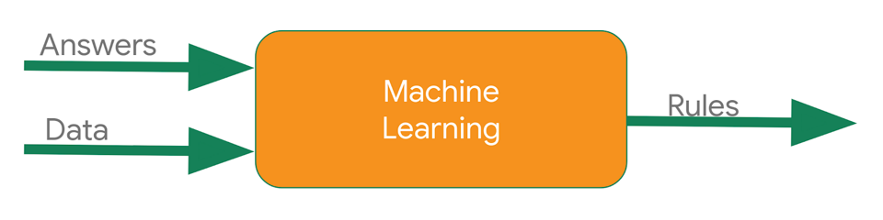

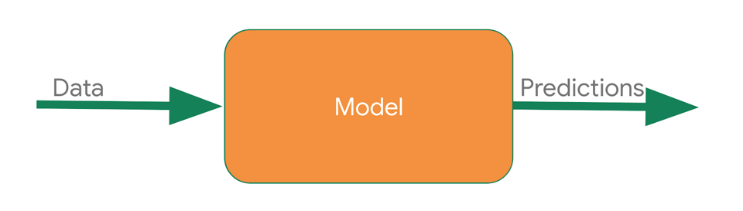

Fig 1.2: Differences between Traditional Programming and Machine learning

**1.3 Creating and Design a ML model:**

1. Data Relationship: Identify the relationship from the given dataset by creating variables x and y.

2. Imports: Import TensorFlow, NumPy, Pandas and Keras for building and training the neural network.

3. Define Neural Network: Create a simple neural network with one layer and one neuron using Keras.

model = tf.keras.Sequential([keras.layers.Dense(units=1, input_shape=[1])])

4. Compile Model: Use mean squared error or accuracy as the loss function depends on classification and regression and an optimizer like Adam and SGD for adjusting the weights of the model and helping the model to learn and improve. Later on train the neural network and test the model.

model.fit(xs, ys, epochs=no of times model goes through training dataset)

5. Provide Data: Use NumPy arrays to feed the x and y variables to the model.

6. Train the Model: Train the neural network to infer the relationship between x and y and create a predictive model.

7. Defining the Model: Use Sequential, Functional API and Model Subclassing to define the layers in the neural network.

8. Layers: Use Flatten and Dense layers for conversion of One dimensional vector and defining the hidden layers with ReLU and softmax Activation functions in model.

8. Predictions: Predict the model and visualize the predictions between actual and predicted. Improving the accuracy of model can be improved by predictions

model.predict(unseen data=image/text)

**1.4 Convolutions and Pooling:**

Convolutions:

Convolutions are fundamental operations in convolutional neural networks (CNNs) that play a crucial role in feature extraction from input data, especially images. A convolution operation involves a filter or kernel sliding over the input data, performing element-wise multiplication, and summing the results to produce a feature map. This process helps detect local patterns such as edges, textures, and shapes in the input image.

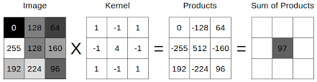

Fig 1.3: Convolution layer

Each filter in a convolutional layer is designed to recognize a specific pattern or feature, and by stacking multiple layers, CNNs can learn increasingly complex and abstract representations. For example, early layers might detect simple edges and corners, while deeper layers can recognize more complex structures like facial features or object parts. Convolutions are also beneficial because they preserve the spatial relationships between pixels, allowing the network to maintain an understanding of the spatial hierarchy in the data.

The use of convolutions significantly reduces the number of parameters compared to fully connected layers, as the same filter is applied across the entire input, leading to weight sharing. This makes CNNs more efficient and less prone to overfitting, especially when working with large images. Convolutions are widely used in various computer vision tasks such as image classification, object detection, and segmentation, making them a cornerstone of modern deep learning approaches in visual data analysis.

Pooling:

Pooling is a critical operation in convolutional neural networks (CNNs) used to reduce the spatial dimensions of feature maps, thereby lowering computational complexity and controlling overfitting. This operation works by sliding a window across the input feature map and applying a pooling function, typically max pooling or average pooling. Max pooling selects the maximum value within the window, preserving the most prominent features, while average pooling calculates the average value, providing a smoother representation. By downsampling the feature maps, pooling helps in creating more abstract representations of the input, enabling the network to recognize patterns and features at various scales and hierarchies. This not only enhances the model's ability to generalize but also makes it more efficient by reducing the number of parameters and the amount of computation required. [[13]](https://developers.google.com/codelabs/tensorflow-3-convolutions?continue=https%3A%2F%2Fdevelopers.google.com%2Flearn%2Fpathways%2Ftensorflow%23codelab-https%3A%2F%2Fdevelopers.google.com%2Fcodelabs%2Ftensorflow-3-convolutions#1)

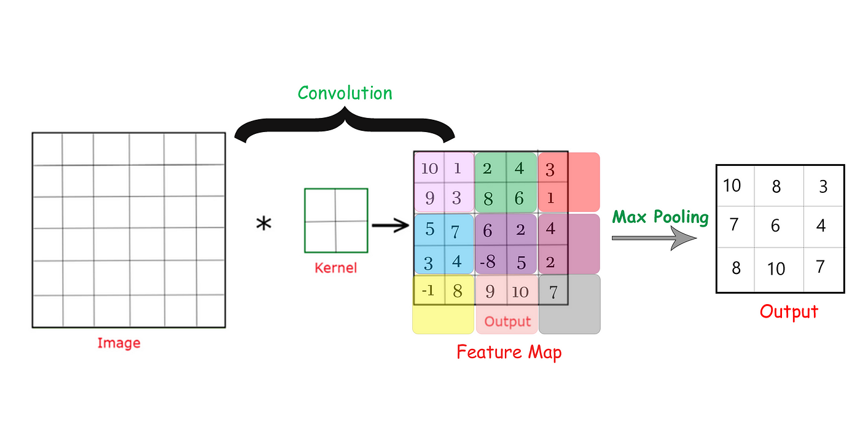

Fig 1.4: Max Pooling layer

Differences between Convolution and Pooling:

|  |  |  |
| --- | --- | --- |
| **Aspect** | **Convolution** | **Pooling** |
| **Purpose** | Extracts features from the input data | Reduces the spatial dimensions of feature maps |
| **Operation** | Applies a filter (kernel) across the input, performing element-wise multiplication and summing the results | Slides a window across the input feature map, applying a pooling function (e.g., max or average pooling) |
| **Output** | Produces a feature map highlighting specific patterns and features in the input | Produces a downsampled feature map, retaining essential information while reducing size |
| **Parameters** | Involves learning filter weights during training | Does not involve learning any parameters; it is a fixed operation |
| **Role in CNN** | Responsible for feature extraction and representation learning | Helps in reducing computational load and controlling overfitting by summarizing features |
| **Spatial Relationships** | Preserves spatial relationships between pixels | Reduces spatial resolution, focusing on significant features |

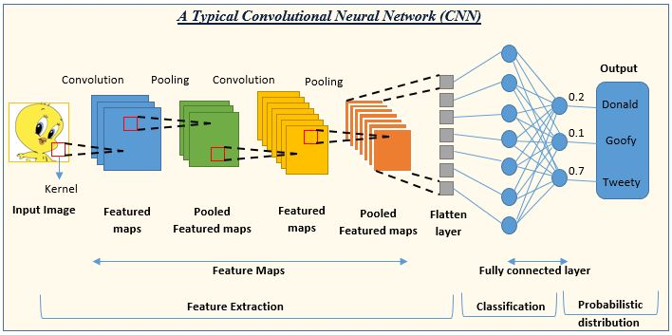

Fig 1.5: The structure of CNN model

**GET STARTED WITH OBJECT DETECTION**

**MODULE 2**

**2.1 Introduction to Object Detection:**

Object detection is a computer vision technique used to identify and locate multiple objects within an image or video. It involves not only classifying objects but also drawing bounding boxes around them to indicate their position. This method is essential in applications like autonomous driving, surveillance, and image analysis, enabling machines to understand and interact with their environment more effectively.

Here are the important factors of Object Detection:

* 1.Identification and Localization: It combines image classification and object localization to detect objects of interest in images or videos.
* 2.Bounding Boxes and Labels: The technique draws bounding boxes around detected objects and labels them accordingly.
* 3.Model Training: Training involves using labeled datasets where each image has annotations specifying the objects and their locations.
* 4.Popular Frameworks: Common frameworks and libraries for object detection include TensorFlow, PyTorch, and OpenCV.
* 5.Applications: It is widely used in autonomous vehicles, surveillance, medical imaging, and retail analytics.

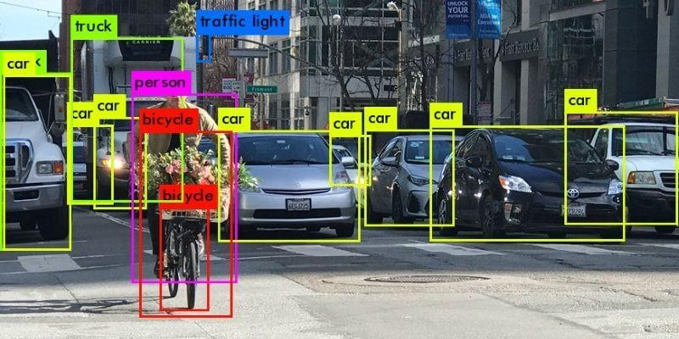

Fig 2.1: Object Detection on vehicles

**2.2** **Build an Object Detector into Mobile App:**

TensorFlow Lite is a cross-platform machine learning library that is optimized for running machine learning models on edge devices, including Android and iOS mobile devices.

TensorFlow Lite is actually the core engine used inside ML Kit to run machine learning models. There are two components in the TensorFlow Lite ecosystem that make it easy to train and deploy machine learning models on mobile devices:

* *Model Maker* is a Python library that makes it easy to train TensorFlow Lite models using your own data with just a few lines of code, no machine learning expertise required.
* *Task Library* is a cross-platform library that makes it easy to deploy TensorFlow Lite models with just a few lines of code in your mobile apps.

Here are the Steps for Object Detector App:

* Introduction: Learn how to integrate an object detector into a mobile app using ML Kit.
* Object Detection Overview: Detect and locate objects in images using ML Kit's API.
* Pre-trained Object Detector: Utilize ML Kit's API for detecting prominent objects in images.
* API Integration: Steps to add ML Kit API, process images, and obtain detection results.
* App Setup: Implement a UI for image selection and integrate object detection methods.
* Dependency Addition: Add ML Kit library to the app's `view.gradle` dependencies.
* Main Activity: Modify the main activity to handle image selection and perform object detection.
* Visualization: Use the app's built-in methods to draw detection results on the input image.

**2.3** **Integrate the Object Detector using ML Kit API:**

There are some steps where a simple model which is based on Object Detection into ML kit app. The below steps are guided to integrating:

* Import Project:
  + Open Android Studio and select "Import Project".
  + Choose the starter folder containing your downloaded source code.
  + This initiates the setup of your project within Android Studio.
* Add Dependencies:
  + Edit the “app/build.gradle” file to include the ML Kit Object Detection and Tracking dependency.
  + Ensure the dependency is correctly formatted and located within the dependencies block.
  + Sync your project with Gradle files to download and integrate the necessary dependencies.
* Run the Starter App:

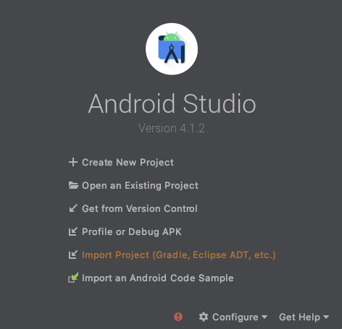

Fig 2.2: Android Studio App Interface

* + Connect your Android device via USB or start an Android Studio emulator.
  + Click "Run" in the Android Studio toolbar to deploy the app on the connected device or emulator.
  + Explore the app's functionalities, such as capturing photos or selecting preset images, to familiarize yourself with its current features.
* Set Up Object Detection:
  + Implement the “runObjectDetection(bitmap: Bitmap)” method in “MainActivity.kt”.
  + This method handles the logic for object detection, preparing image data and passing it to the ML Kit object detection module.
  + Ensure the method is structured to process image data and manage the detection results effectively.
* Process the Image:
  + Feed the selected image into the ML Kit object detector using the `objectDetector.process(image)` method.
  + Configure a callback mechanism (`addOnSuccessListener` and `addOnFailureListener`) to asynchronously receive and handle detection results.
  + This approach ensures that object detection tasks are executed efficiently without blocking the main UI thread.
* Print Detection Results:

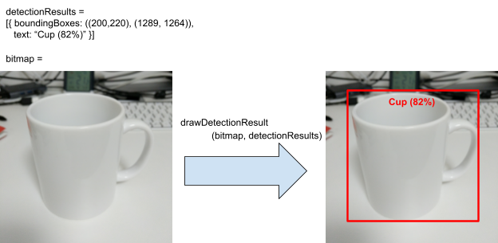

Fig 2.3: Displaying the result of Object

* + Implement the `debugPrint(detectedObjects: List<DetectedObject>)` method in `MainActivity.kt`
  + Log detection results such as object coordinates, classification labels, and confidence scores.
  + This logging helps developers debug and understand the outcomes of object detection processes.
* Visualize Detection Results:
  + Replace the `debugPrint` call with visualization code that draws bounding boxes around detected objects on the image.
  + Display corresponding labels and confidence levels within or near the bounding boxes.
  + Enhance the app's user interface by visually presenting detected objects, making it easier for users to interpret and interact with detection outcomes.
* Run and Test:
* Click "Run" in the Android Studio toolbar to compile and deploy your app with integrated ML Kit object detection functionality.
* Use the app's camera feature to capture new photos or select preset images for detection.
* Observe how the app displays detection results directly on the screen, confirming the successful integration of ML Kit's capabilities into your Android app.

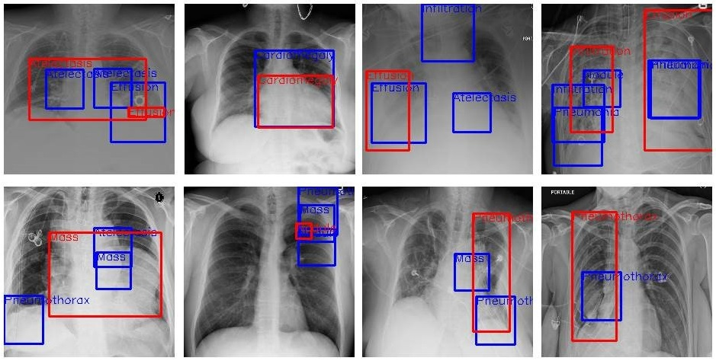

Fig 2.4: X-ray object(disease) detection

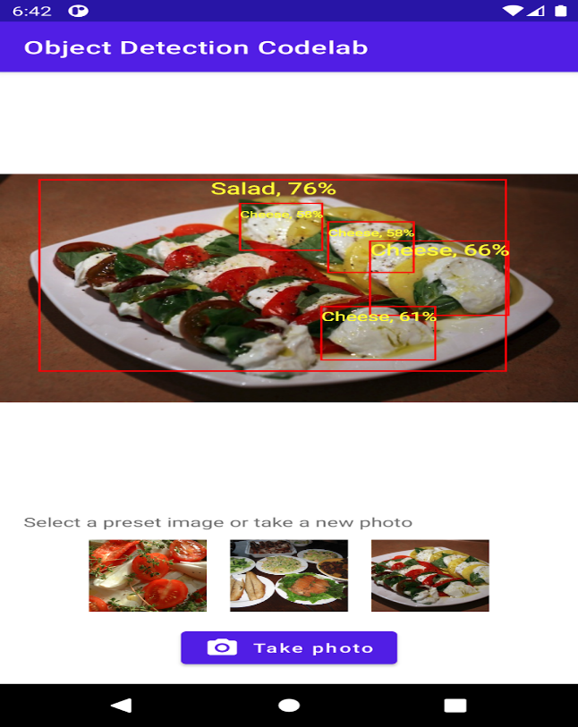

Fig 2.5: The Android App detecting the object

This structured approach ensures systematic integration and utilization of ML Kit for object detection, enhancing your app's functionality with machine learning-powered features.

**GO FURTHER WITH OBJECT DETECTION**

**MODULE 3**

**3.1 Training the model:**

Training the Object Detection model:

There are some steps where a model can be trained so that accuracy of testing dataset and unseen dataset will be better as training dataset. So these are steps :

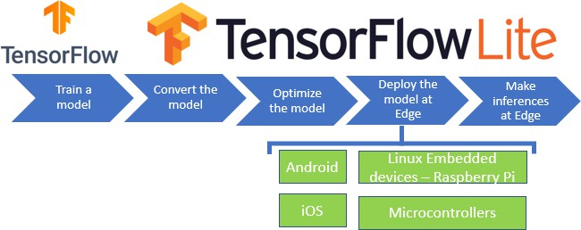

Fig 3.1: TensorFlowLite

* Data Collection:
  + Sources: Utilize public datasets like COCO or PASCAL VOC. Collect custom data from cameras or online sources.
  + Annotation Tools: Use tools such as LabelImg or VGG Image Annotator (VIA) to annotate images with bounding boxes and labels.
* Data Preparation:
  + Directory Structure: Organize data into train, validation, and test sets.
  + Data Augmentation: Apply techniques like rotation, scaling, flipping, and color adjustments using libraries like `imgaug` or TensorFlow's `tf.image`.
* Model Selection:
  + Pre-trained Models: Choose architectures like Faster R-CNN, YOLO, or SSD. Fine-tune models on your specific dataset.
  + Custom Architecture (Optional): Design neural networks tailored to specific requirements.
* Training the Model:
  + Environment Setup: Use virtualenv or conda for isolation. Install TensorFlow, Keras, and OpenCV.
  + Training Script: Load and preprocess data, define and compile the model, and train with appropriate hyperparameters.
* Evaluation:
  + Metrics: Assess performance using accuracy, precision, recall, F1-score, and mAP. Generate and analyze confusion matrices.
  + Validation and Testing: Evaluate on separate validation and test sets. Visualize predictions for further analysis.
* Deployment:
  + Exporting: Save models as SavedModel or convert to TensorFlow Lite for mobile deployment.
  + Integration: Deploy using TensorFlow Serving for scalability, Flasfor web, or TensorFlow Lite for mobile applications.

**3.2 Deploying the model in Android Studio:**

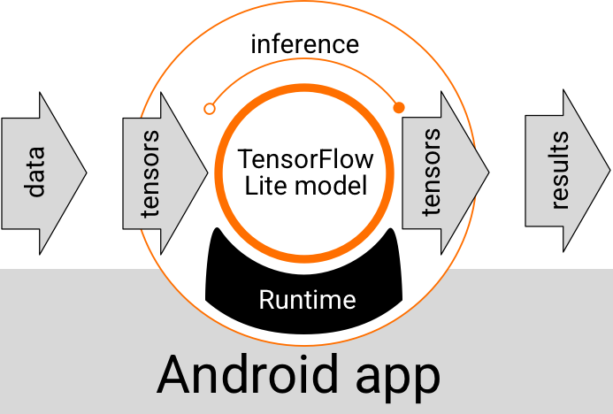

Fig 3.2: Android app

Android Object Detection App Overview:

* Starter App Boilerplate Code:
  + Camera Integration: Captures photos using the device's camera.
  + Stock Images: Includes preset images for testing on an emulator.
  + Drawing Results: Convenient method to overlay detection results on images.
* Key Methods:
* runObjectDetection(bitmap: Bitmap) :
  + Called when a photo is taken or a preset image is chosen.
  + `bitmap` is the input image for object detection.
  + You'll add the object detection logic to this method.
* DetectionResult Data Class :
  + Represents an object detection result.
  + Attributes:
  + `boundingBoxes`: Rectangle indicating the object's location.
  + `text`: Detection result string to display with the bounding box.
* drawDetectionResult :
  + Draws detection results on the input bitmap.
  + Returns the modified bitmap with the detection results overlaid.

These methods help streamline the object detection process, focusing on integrating machine learning with the app's functionality.

**3.3 Setting Up and Running Object Detection on an Android App:**

* Add the Model to the App:
  + Copy the `model.tflite` file to the `assets` folder in the starter app.
  + Ensure the model file is named `model.tflite.

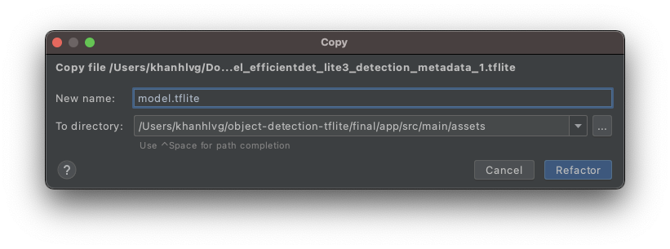 Fig 3.3: Adding the model to the file

* Update Gradle File:
  + Open `app/build.gradle`.
  + Add the following line to the `dependencies` section:
  + Sync your project with Gradle files.

**implementation 'org.tensorflow:tensorflow-lite-task-vision:0.3.1'**

* Setup Object Detection in `MainActivity.kt`:
  + Create TensorImage Object:
* Create TFLite's TensorImage object
* Initialize the detector object
* Print Detection Results:
  + Add a method to print detection results to Logcat:
  + Call this method in `runObjectDetection`:
* Compile and Run the App:
  + Click on the Run button in Android Studio.
  + Once the app is running on the device/emulator, tap on a preset image to start object detection.
  + Check the Logcat window for detection results.

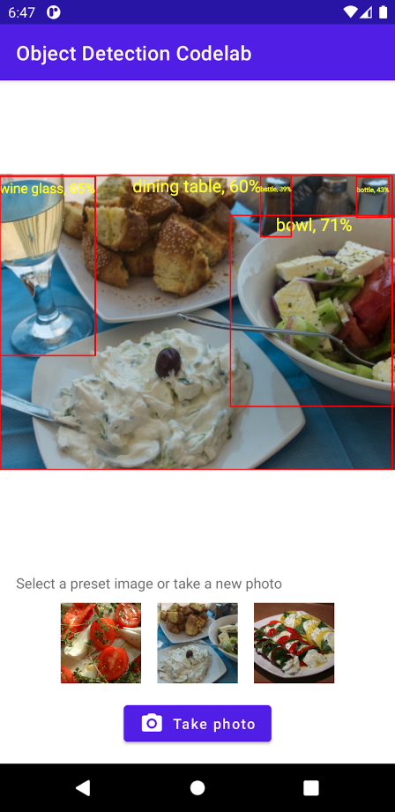

Fig 3.4: Object Detection in Android App.

**3.4 Display Detection Results on Image:**

* Replace Logcat Printing with UI Update:
* Modify `runObjectDetection` to create a list of `DetectionResult` and update the UI with bounding boxes and label.
* Run Detection on Background Thread:
  + Use a Kotlin coroutine to run `runObjectDetection` on a background thread to avoid blocking the UI
* Run and Test the App:
  + Click the Run button in Android Studio.
  + Tap on one of the preset images in the app to see the detection results displayed with bounding boxes and labels.

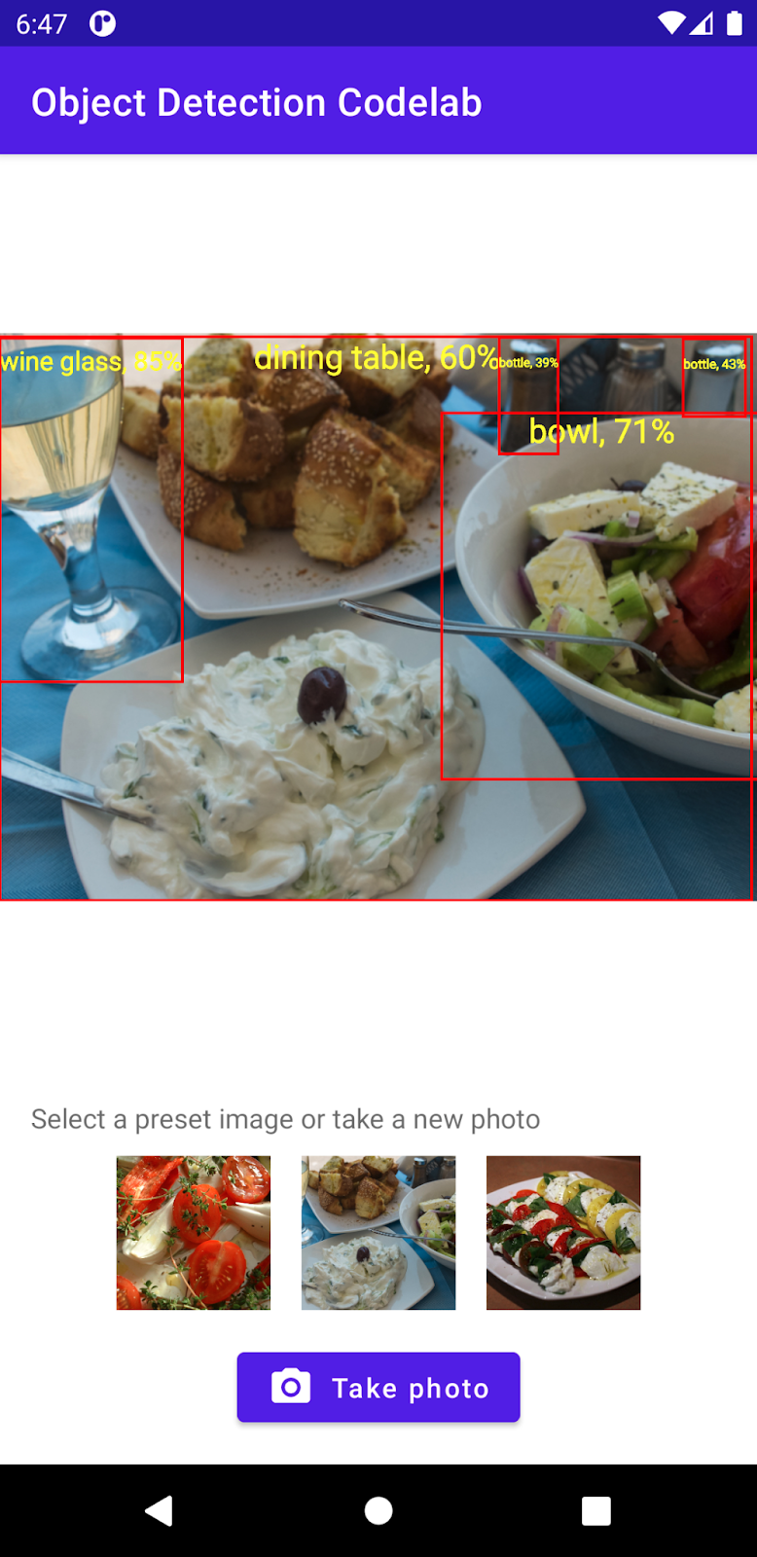

Fig 3.5: Object Detection with probabilty

**GET STARTED WITH PRODUCT IMAGE SEARCH**

**MODULE 4**

**4.1 Introduction:**

* Imagine spotting a cool item on the street and wanting to buy it online. With a smartphone, you can point the camera at the product and instantly find online shops selling similar items.
* Google Lens offers this feature, and you can integrate a similar functionality into your mobile app to let users search for visually similar products within your catalog.
* There are two main components to build this feature.
* The first component is an on-device object detector that identifies prominent objects in the image and suggests to users which object to search for. This can be built using the ML Kit Object Detection and Tracking API.
* The second component is a product search backend. Given the potentially large size of your product catalog, it's crucial to manage and search through this catalog efficiently to suggest relevant products to users.

**4.2 Build an Object Detector into Your Mobile App:**

* When a user captures an image, we want them to specify which object they want to search for in our catalog.
* First, detect objects in the image, then display the detection results, and finally, let the user choose the object to search for.
* Implement the Object Detector using ML Kit's Object Detection and Tracking API.
* ML Kit offers easy-to-use APIs for integrating machine learning into your mobile app without requiring expertise.
* We'll start with a skeleton app that has boilerplate UI code for taking photos or loading images.
* Add ML Kit to the app dependency by modifying the build.gradle file.

In the main activity, find the method called when an image is selected, and add the object detection code.

* There are three steps to using the ML Kit Object Detection API: create an input image, create an Object Detection Client, and enable multiple objects and classification options.
* Feed the input image to the detector and print the detection result, which includes a bounding box and labels for each detected object.
* Run the app to see the model detect fashion items with a high confidence score.
* Draw detection results on the app UI, allowing users to select the object they want to search for by tapping on the dot.
* Download the source code from the code lab in the learning pathway to follow along and implement these steps.

Remember, good design is crucial for building a successful app.

**4.3 Detect Objects in Images to Build a Visual Product Search:**

* Choose a pre-trained object detection model such as SSD MobileNet or Faster R-CNN.
* Convert the model to TensorFlow Lite format using TensorFlow Lite Converter for mobile compatibility.
* Set up your Android project in Android Studio or your preferred IDE.
* Integrate the TensorFlow Lite model by placing the `.tflite` file in the assets folder and adding the TensorFlow Lite dependency in your `build.gradle` file.
* Develop logic to capture images using the device’s camera or to select them from the gallery.
* Use TensorFlow Lite Interpreter to perform object detection on images, extracting detected objects' information, classes, and bounding box coordinates.
* Implement UI elements to display detection results, providing users with an intuitive visual product search interface.
* Refine and optimize the feature for performance and user experience.
* Test thoroughly on different devices to ensure reliable functionality.
* Ensure a smooth user experience by continually refining the detection process and UI feedback.

- Finalize by optimizing for performance to handle various device specifications.

**GO FURTHER WITH PRODUCT IMAGE SEARCH**

**MODULE 5**

**5.1 Call the Product Search Backend from the Mobile App**

* Use Google Cloud Vision API product search to build a backend with your product catalog, requiring no machine learning expertise.
* Each backend lives in a Google Cloud project; you need the project ID to call the backend.
* Deploy the product search backend in a chosen Google Cloud location, noting the location ID for later use.
* A product set acts as a container for a group of products in your catalog.
* Create multiple products and add them to the product set after creating it.
* Reference images provide various views of your products, helping to search for visually similar items.
* Query the product set using the Cloud Vision API once it's indexed.
* Creating a product search backend with Vision API product search is straightforward but requires setting up a Google Cloud account with billing enabled.
* A demo product search backend is provided, built using Vision API product search and a catalog of around 100 dresses and shoes.
* An API key is needed to call the Vision API product search from a mobile app.
* A proxy endpoint simplifies the demo backend by adding authentication factors like the API key and forwarding requests to the Vision API product search.
* The proxy endpoint receives responses from the Vision API and passes them to the app.
* The starter app contains code configuring the demo backend in the product search API client class.
* To use your own product search backend, change the demo backend's API endpoint to the Vision API endpoint, inputting your API key, project ID, location ID, and product set ID.

The rest of the code remains the same, ensuring consistency and ease of integration.

These are the steps to Call the Product Search Backend from the Android App

* + - Set Up Backend API:
      * Develop an API on your backend server to manage product search requests.
      * Create endpoints to accept images or image URLs for product searches.
      * Implement logic on the server side to use Vision API Product Search or another suitable technology for product search.
      * Ensure the API returns results in a structured format like JSON.
    - HTTP Request from Android App:
      * Integrate an HTTP client library such as Retrofit, Volley, or OkHttp into your Android app.
      * Configure the client to send requests to the backend API's endpoints.
    - Prepare Image Data:
      * Prepare the image data for the request, possibly encoding it in a suitable format like Base64.
      * Ensure the image data is correctly included in the request payload.
    - Send HTTP Request:
      * Use the HTTP client library to send a POST request to the backend API's product search endpoint.
      * Include the prepared image data in the request body.
    - Handle Response:
      * Implement logic to handle the response from the backend API.
      * Parse the JSON response to extract product search results.
      * Display the results in the app's UI, allowing users to view similar products or make purchases.
    - Error Handling:
      * Implement graceful error handling for scenarios like network or server-side errors.

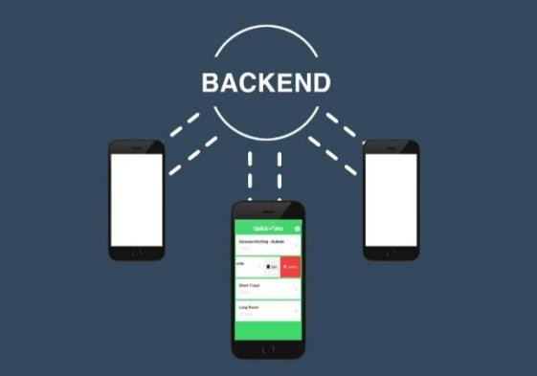

Fig 5.1: Backend for Mobile Application

**5.2 Build a Visual Product Search Backend Using Vision API Product Search**

* Set Up GCP:
* Create a project on Google Cloud Platform (GCP) and enable the Vision API and Product Search API.
* Generate service account credentials for secure API access.
* Upload Product Data:
  + Upload product images and metadata to Cloud Storage or the Cloud Console.
  + Use the Product Search API to create product sets and add individual products with associated images and metadata.
* Index Product Images:
  + Index product images using the Vision API Product Search to extract features and make them searchable.
* Develop API Endpoint:
  + Create an API endpoint on your backend server to handle product search requests.
  + Utilize Vision API Product Search to perform similarity searches based on provided images.
* Return Search Results:
  + Return search results to the client in a structured format like JSON, including metadata for each product.
* Optimize and Secure:
  + Ensure your backend is scalable and optimized, using caching and efficient indexing.
  + Implement proper authentication and authorization, use HTTPS for encryption, and validate user input to enhance security.

Through these steps, you can build a robust visual product search backend that delivers accurate and relevant search results based on visual queries.

**GET STARTED WITH IMAGE CLASSIFICATION**

**MODULE 6**

**6.1 Introduction to Image Classification:**

Image classification refers to the process of categorizing images into predefined classes or categories based on their visual content. Here are the key points to understand about image classification:

* Definition: Image classification is a computer vision task where an algorithm analyzes the content of an image and assigns it to one or more predefined classes or categories.
* Input and Output: It takes an image as input and outputs a label or a set of labels that describe what is depicted in the image. Each label corresponds to a specific class or category.
* Applications: It is widely used in various applications such as:
  + **Medical Imaging: Diagnosing diseases from medical scans(X-rays).**
  + Object Recognition: Identifying objects in photos for autonomous vehicles or robotics.
  + Visual Search: Powering search engines that retrieve images based on their content.
  + Security: Facial recognition for authentication and surveillance.
* Techniques: Image classification algorithms often employ deep learning techniques, particularly convolutional neural networks (CNNs). These networks learn hierarchical features from images, enabling them to differentiate between classes based on patterns, textures, and shapes.
* Performance Metrics: Evaluation of image classification models is typically done using metrics like accuracy, precision, recall, and F1-score, which measure how well the model predicts the correct labels for unseen images.

Creating a custom image classifier involves several steps, from gathering and preparing your dataset to training and deploying the model. Here's a structured approach to create a custom model for your image classifier.

**6.2 Steps to Create a Custom Image Classifier:**

* Define Your Problem and Gather Data:
  + Clearly define what you want your model to classify (e.g., types of flowers, handwritten digits).
  + Gather a dataset that is representative of the classes you want to classify. Ensure the dataset is diverse and has enough examples per class for effective training.
* Prepare Your Dataset:
  + Data Preprocessing:
  + Resize images to a uniform size (e.g., 224x224 pixels) suitable for your model architecture.
  + Normalize pixel values (typically between 0 and 1) to facilitate model training.
  + Augment your dataset if needed (e.g., rotate, flip, zoom images) to increase variability and improve generalization.
* Choose a Model Architecture:
  + Select an appropriate neural network architecture suited to your classification task.
  + Popular choices include Convolutional Neural Networks (CNNs) such as VGG, ResNet, or custom architectures tailored to specific requirements.
* Set Up Your Development Environment:
  + Use a deep learning framework such as TensorFlow, PyTorch, or Keras.
  + Ensure necessary libraries and tools are installed for data processing, model training, and evaluation.
* Model Training:
  + Transfer Learning (Optional):
  + If your dataset is small, consider using transfer learning with a pre-trained model as a base. This approach can save time and improve performance.
  + Training:
  + Initialize your model with appropriate weights.
  + Train your model on the prepared dataset using techniques like stochastic gradient descent (SGD) with backpropagation.
  + Monitor training metrics (e.g., loss, accuracy) and adjust hyperparameters as needed (learning rate, batch size, number of epochs).
* Evaluate Your Model:
  + Use a separate validation set to evaluate your model's performance.
  + Compute metrics such as accuracy, precision, recall, and F1-score to assess classification performance.
* Fine-tune and Optimize:
  + Fine-tune your model based on evaluation results and insights gained from analyzing misclassifications.
  + Optimize your model for deployment, considering factors like inference speed and model size.
* Deploy Your Model:
  + Prepare your model for deployment in your desired environment (e.g., mobile app, web service).
  + Convert your model to a format compatible with your deployment platform (e.g., TensorFlow Lite for mobile devices).
  + Integrate your model into your application and ensure it functions correctly in a production environment.
* Monitor and Maintain:
  + Continuously monitor your model's performance post-deployment.
  + Periodically retrain your model with new data to maintain accuracy and adapt to changing conditions.
* Iterate and Improve:
  + Based on feedback and usage patterns, iterate on your model to improve performance or add new features.

By following these steps, you can systematically create and deploy a custom image classifier tailored to your specific application requirements. Each step involves careful consideration and experimentation to achieve the best results.

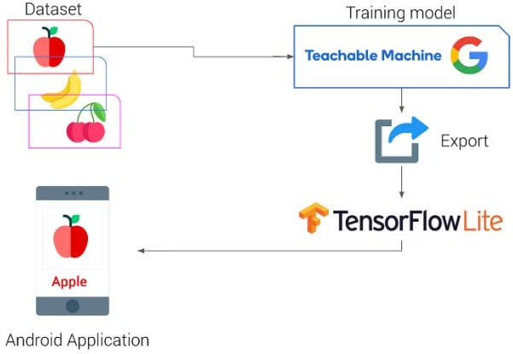

Fig 6.1: Image Classification using TensorFlowLite

**6.3 Integrating the model into App:**

Integrating a custom model into your app involves several key steps to ensure seamless functionality and optimal performance. Here’s a structured approach to integrate a custom model (for example, an image classifier) into your app:

Steps to Integrate a Custom Model into Your App

* Prepare Your Custom Model:
  + Train and Export: Train your custom model using a deep learning framework (e.g., TensorFlow, PyTorch) on your dataset. Export the trained model in a format compatible with deployment (e.g., TensorFlow SavedModel, TensorFlow Lite, ONNX).
* Choose Your Deployment Platform:
  + Determine where your app will run and select the appropriate deployment platform. Options include:
  + Mobile Devices: Android (using Android Studio) or iOS (using Xcode).
  + Web: Integrate into web applications using frameworks like TensorFlow.js.
  + Desktop: Deploy on desktop applications using appropriate libraries and frameworks.
* Convert Your Model (if necessary):
  + Depending on your deployment platform, convert your model to an appropriate format:
  + TensorFlow Lite: For Android and iOS mobile devices, use TensorFlow Lite to optimize and deploy your model.
  + Core ML: For iOS, convert your model to Core ML format using tools provided by Apple.
  + ONNX Runtime: For cross-platform deployment, use ONNX Runtime with ONNX models.
* Integrate into Your App Project:
  + Android Studio:
  + Add your model file (e.g., `.tflite` file for TensorFlow Lite) to the `assets` folder of your Android Studio project.
  + Update your `build.gradle` file to include dependencies needed for inference (e.g., TensorFlow Lite Task Library).
  + iOS (Xcode):
  + Include your model file in the Xcode project structure.
  + Update project settings to ensure proper integration with Core ML or other frameworks.

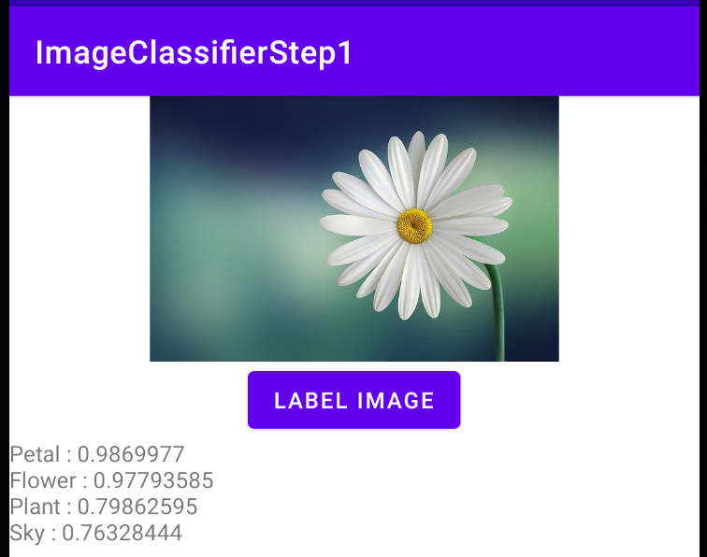

Fig 6.2: Flower Image Classification with probabilities

* Develop Model Inference Code:
  + Write code in your app to load the model and perform inference:
  + Android (Kotlin/Java):
  + Initialize the TensorFlow Lite interpreter and load the model.
  + Prepare input data (e.g., images) and feed it into the model for inference.
  + Process output from the model (e.g., classification results).
  + iOS (Swift/Objective-C):
  + Use Core ML to load the model and perform inference.
  + Prepare input data and process output similar to Android.
* Handle Input Data:
  + Implement mechanisms to capture input data (e.g., images from camera, gallery, or files).
  + Convert input data into a format suitable for model inference (e.g., resize images, normalize pixel values).
* Display Results:
  + Visualize model predictions or results within your app’s user interface:
  + Display classification labels, bounding boxes, or other relevant information based on your model’s output.
* Optimize for Performance:
  + Optimize model inference for speed and efficiency, especially on mobile devices with limited resources:
  + Use techniques such as batching inference requests and optimizing memory usage.
  + Consider hardware acceleration options available on platforms (e.g., GPU acceleration on Android devices).
* Testing and Validation:
  + Test your app thoroughly to ensure that model inference works correctly across different scenarios and input data.

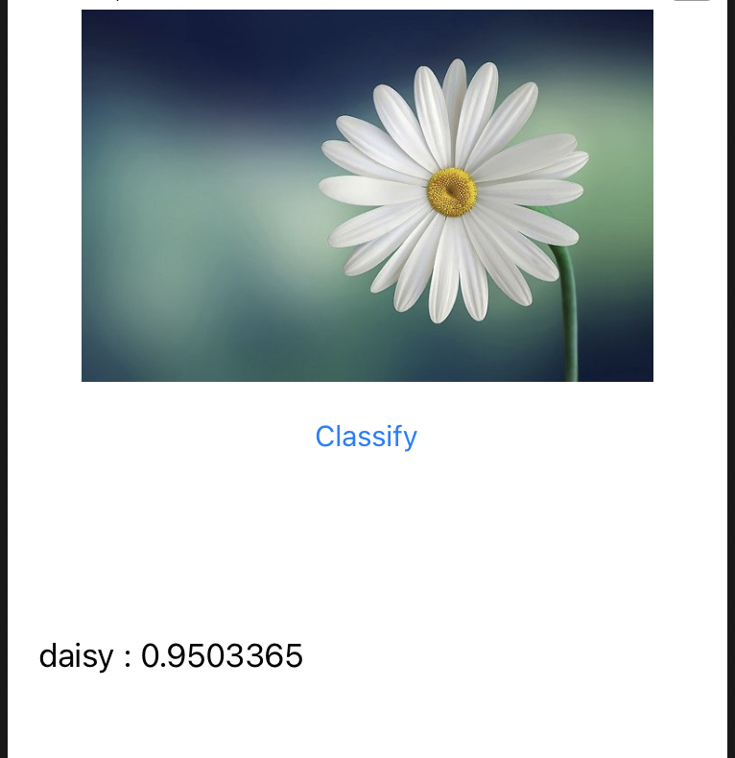

Fig 6.3: Flower Image Classfication in Mobile App

* + Validate performance metrics such as inference speed, accuracy, and resource consumption.
* Deploy and Monitor:
  + Deploy your app with integrated custom model to your target platform (Google Play Store, Apple App Store, web hosting).
  + Monitor app performance and user feedback post-deployment.
  + Iterate and improve based on insights gathered from usage analytics and user interactions.

By following these steps, you can effectively integrate a custom machine learning model into your app, enhancing its functionality with AI-driven capabilities tailored to your specific application needs. Each step involves careful implementation and testing to ensure a seamless user experience and reliable performance.

**7. CASE STUDY**

**Development of a Web-Based X-ray Image Disease Classification System**

**Problem Statement:**

In medical diagnostics, accurate X-ray classification is vital for effective treatment. Current manual methods can lead to errors and delays. This project aims to develop a CNN-based system to automate chest X-ray classification, focusing on distinguishing pneumonia from normal lungs, to enhance diagnostic accuracy and efficiency

**Solution Overview:**

This procedure outlines the steps to build an Android application for smart retail using TensorFlow Lite for object detection on product shelves. Note that this is a high-level guide, and each step might involve additional sub-tasks depending on your specific needs.

**Data Collection and Preprocessing:**

* Image Dataset: Take high-resolution pictures of store shelves with various products, ensuring different lighting conditions and arrangements. Include close-ups for small items and barcodes. [[5]](https://www.kaggle.com/datasets/prashant268/chest-xray-covid19-pneumonia)

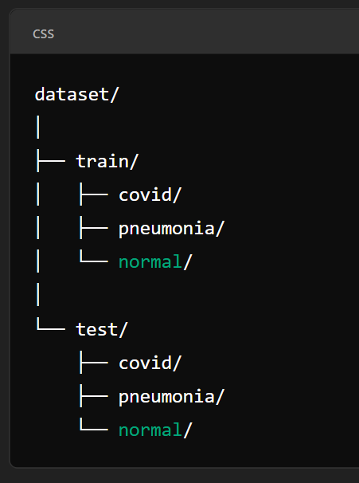

Fig 7.1 represents the directory of the taken dataset

* Data Splitting: Divide labeled data into training, validation, and test sets. Use the training set to train the model, the validation set to fine-tune hyperparameters, and the test set to evaluate final model performance.
* Training dataset images = 5144
* Testing dataset images = 1288
* Total images in dataset = 6432
* Total classes = 3

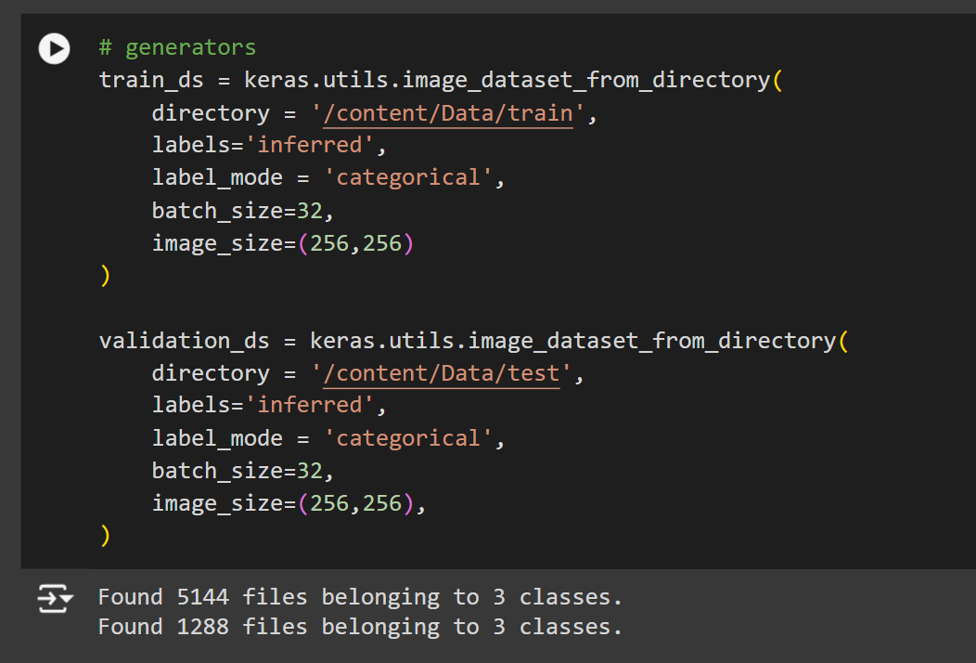

Fig 7.2 represents generators used for training and validation

* Preprocessing:
* Resize images to a consistent size required by the model.
* Normalize pixel values, typically converting to a range of 0-1.
* Apply Normalization and Dropout techinques to increase data variety and improve model generalizability.

This version captures the essential steps of your data collection and preprocessing process in a clear and concise manner.

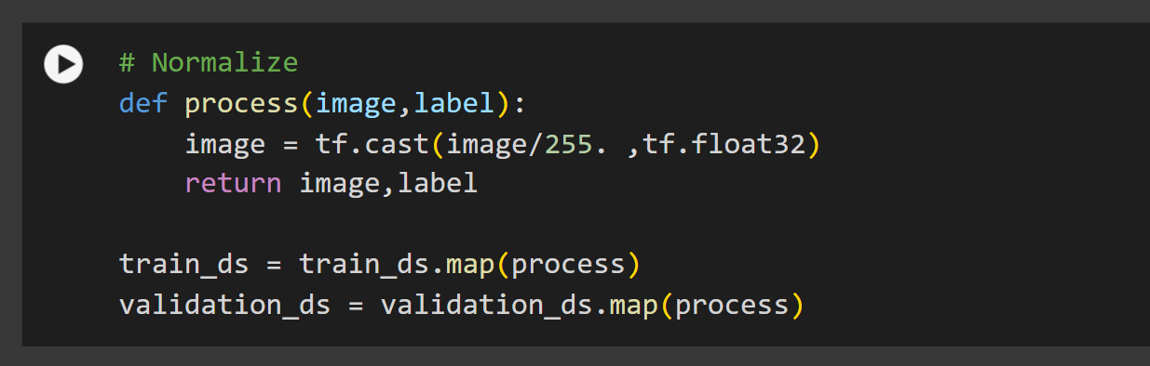

Fig 7.3 represents the preprocessing of image in dataset

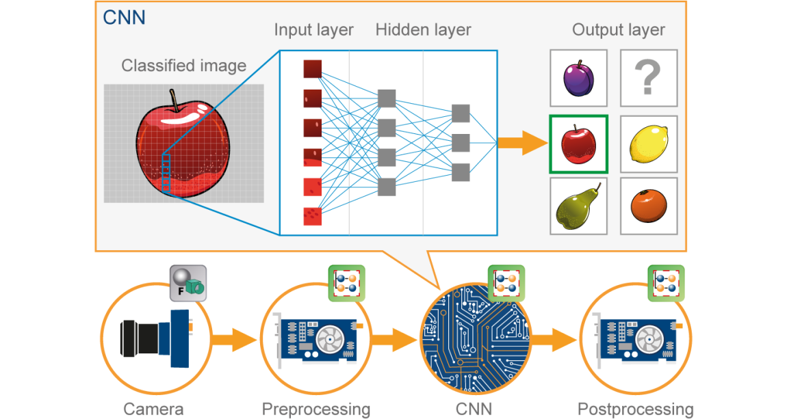

Fig 7.4 represents the working of CNN model

**Model Selection and Training (Using Python):**

* Objective: Develop a robust image classification model to accurately categorize images (e.g., X-ray images of different conditions).
* Data Preparation: Collect and preprocess data, including resizing, normalization.
* Model Architecture: Choose and implement a Convolutional Neural Network (CNN) or other suitable architecture for the classification task.

The CNN model begins by importing essential modules from TensorFlow's Keras API. These include the Sequential model, which allows for the construction of a linear stack of layers, and various layer types such as convolutional, batch normalization, max pooling, flatten, dense, and dropout layers.

* A sequential model is initialized, setting up a container where layers will be added sequentially.

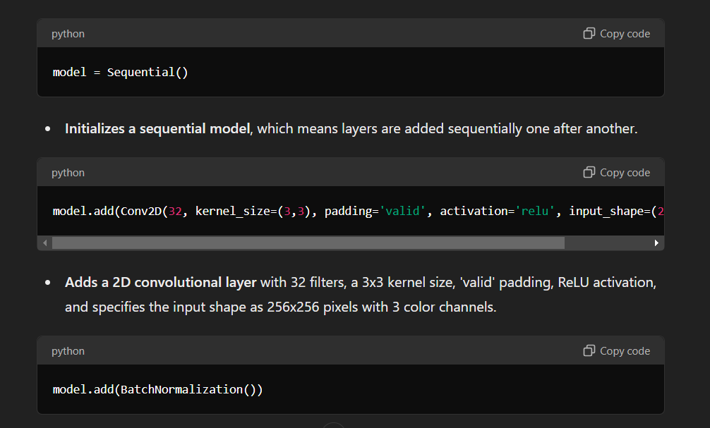

* The first layer added is a 2D convolutional layer with 32 filters and a 3x3 kernel size. This layer uses 'valid' padding, meaning no padding is added around the input, and ReLU activation, which introduces non-linearity to the model. The input shape is specified as 256x256 pixels with 3 color channels, defining the dimensions of the input images.



ext, a batch normalization layer is added to normalize the activations of the previous convolutional layer, which helps speed up training and improves model stability.



* A max pooling layer is then added with a 2x2 pool size and a stride of 2. This layer reduces the spatial dimensions of the feature map by selecting the maximum value in each 2x2 window, effectively downsampling the input.

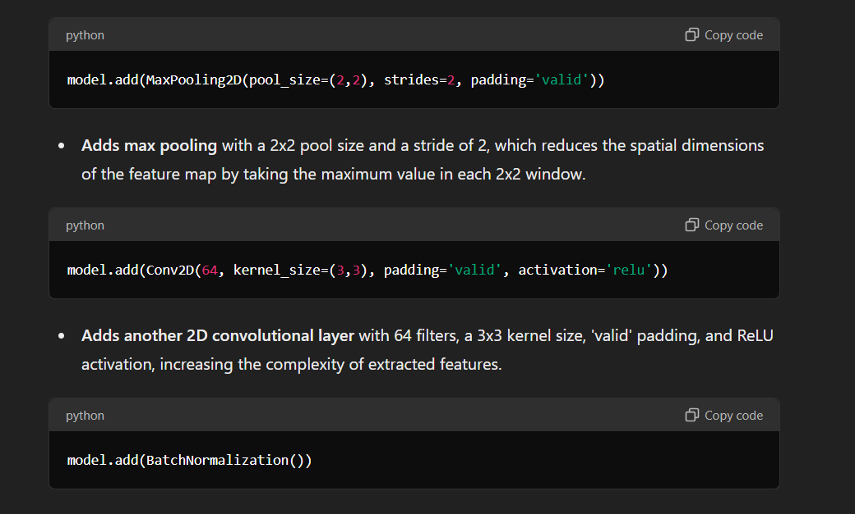

* The process is repeated with a second convolutional layer, this time with 64 filters, followed by another batch normalization layer. This increases the complexity of the features extracted from the images.



* Another max pooling layer is added to further reduce the spatial dimensions.
* A third convolutional layer with 128 filters is added, followed by batch normalization to handle more complex features.

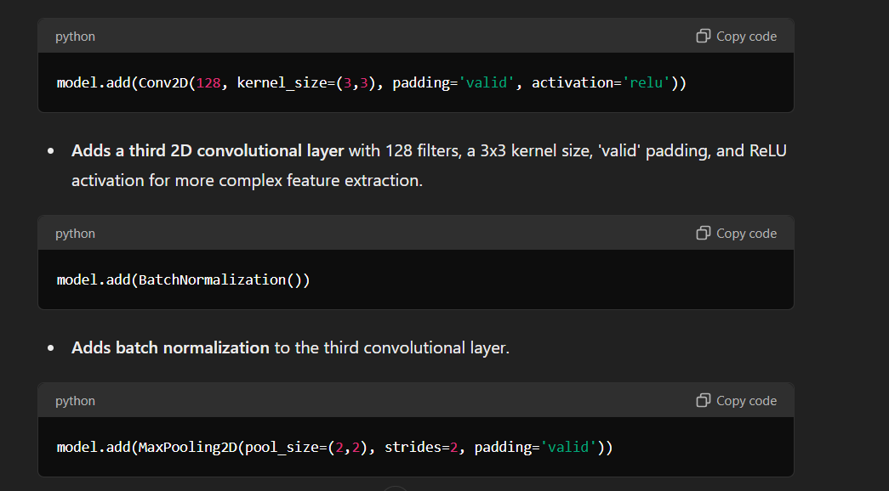

* A third max pooling layer is added to further downsample the feature map.
* The output from the convolutional layers is then flattened into a one-dimensional array, preparing it for the dense layers that follow.

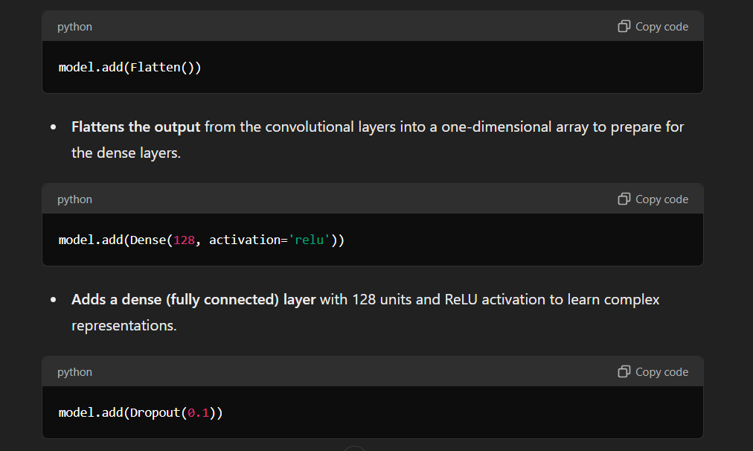

* The first dense (fully connected) layer with 128 units and ReLU activation is added, allowing the model to learn more complex representations.



* To prevent overfitting, a dropout layer with a rate of 0.1 is added, which randomly sets 10% of the input units to zero during training.



* A second dense layer with 64 units and ReLU activation is added for further representation learning, followed by another dropout layer with a rate of 0.1 for regularization.

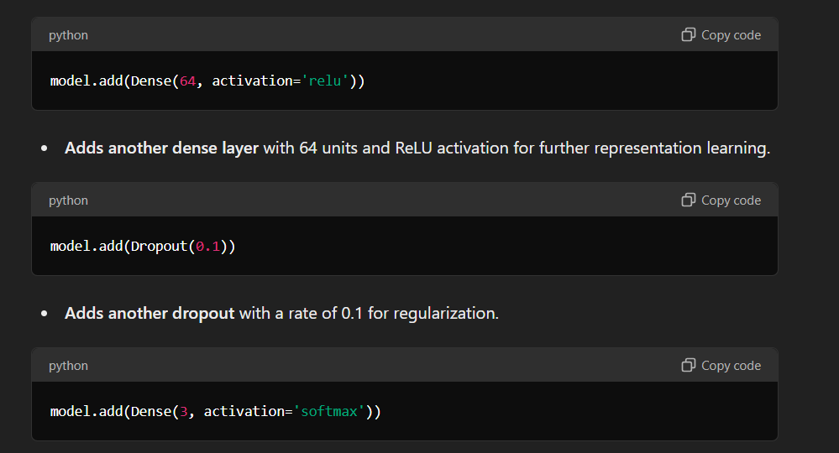

* Finally, the output layer is a dense layer with 3 units and a softmax activation function, indicating that the model is designed for a three-class classification problem. The softmax function ensures that the output is a probability distribution over the three classes.



* Training Process: Train the model using labeled data, adjusting hyperparameters to optimize performance. Monitor metrics such as accuracy and loss to evaluate the training progress.

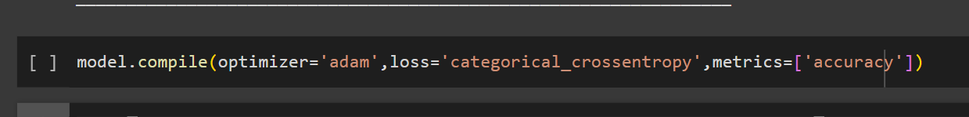

* Optimizer : Adam(Adaptive Moment Estimation)
* Loss : Categorical (Multi class Label)
* Metrics : Accuracy (Classification)
* Fitting the model: The code trains the neural network model using the `fit` method, where `train_ds` is the training dataset and `validation_ds` is the validation dataset. The training process runs for one epoch, meaning the model will see each training sample once. The `fit` method also tracks the training and validation performance, which is stored in the `history` object for later analysis.



* Evaluation Metrics:
* Training accuracy = 0.96 and Testing accuracy = 0.93
* Train loss = 0.0872 and Test loss = 0.2576
* Training Precision = 0.96 and Test Precision = 0.93
* Train Recall score = 0.96 and Test Recall score = 0.93

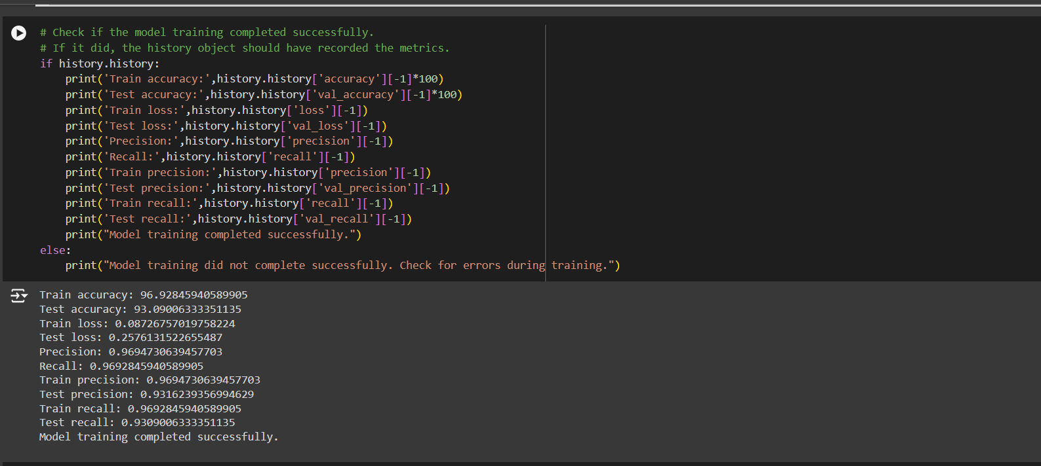

Fig 7.5 represents the evaluated metrics of model

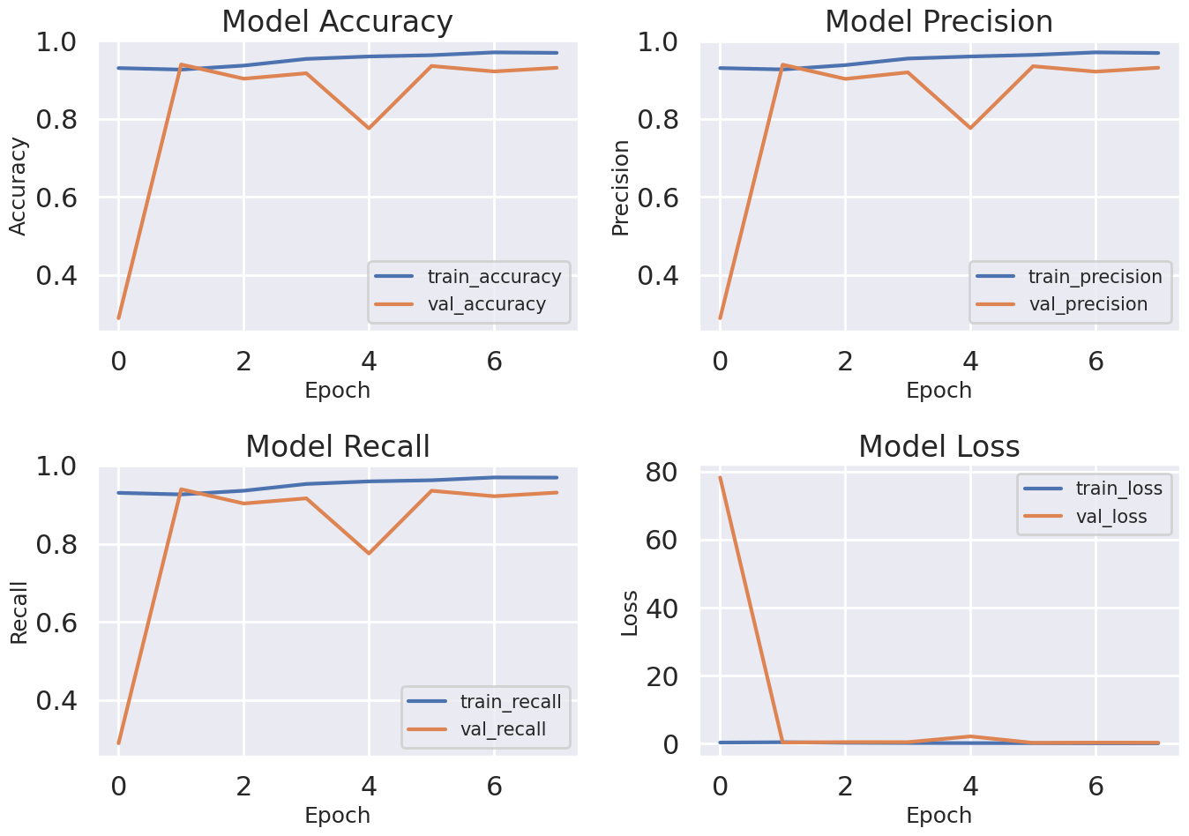 Fig 7.6 represents plot of metrics during epochs

**Model Conversion and Optimization Using NGrok:**

* Model Conversion: Convert the trained model into TensorFlow Lite format to enable deployment on mobile devices. Use the TensorFlow Lite Converter to create a `.tflite` file from the trained model.
* Optimization Techniques: Apply quantization to reduce model size and enhance performance. This step may involve converting the model to use integer values instead of floating-point numbers.
* Using NGrok: Leverage NGrok to expose local development environments for remote testing and integration. NGrok provides secure tunnels to your local server, enabling you to access and test the model conversion and optimization process remotely.

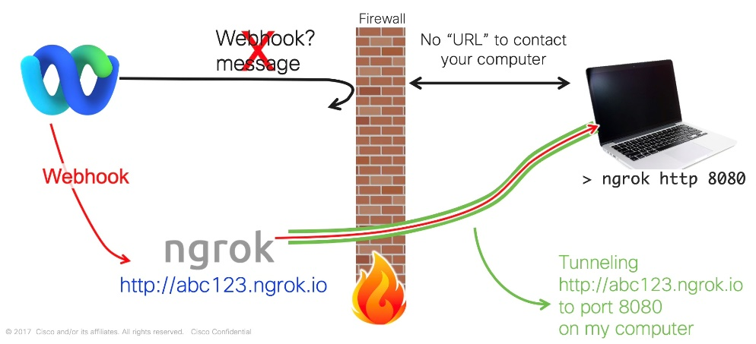

Fig 7.7 represents the working of ngrok website

**Website using Ngrok:**

* Start Your Local Server: Run your local web server (e.g., Flask or Node.js) on a specified port.
* Run NGrok: Execute `ngrok http <port>` in your terminal to create a public URL for your local server.
* Access and Share: Use the NGrok-provided public URL to remotely access and test your application, sharing it with others as needed.
* Security: Monitor access and secure sensitive data, shutting down NGrok when testing is complete.

**Image Preprocess part**:

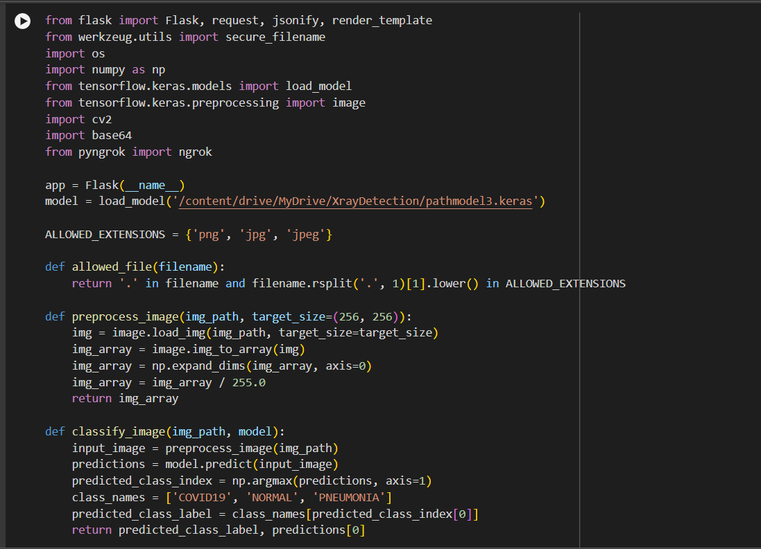

Fig 7.8 represents the preprocess part of Website

**Backend part**:

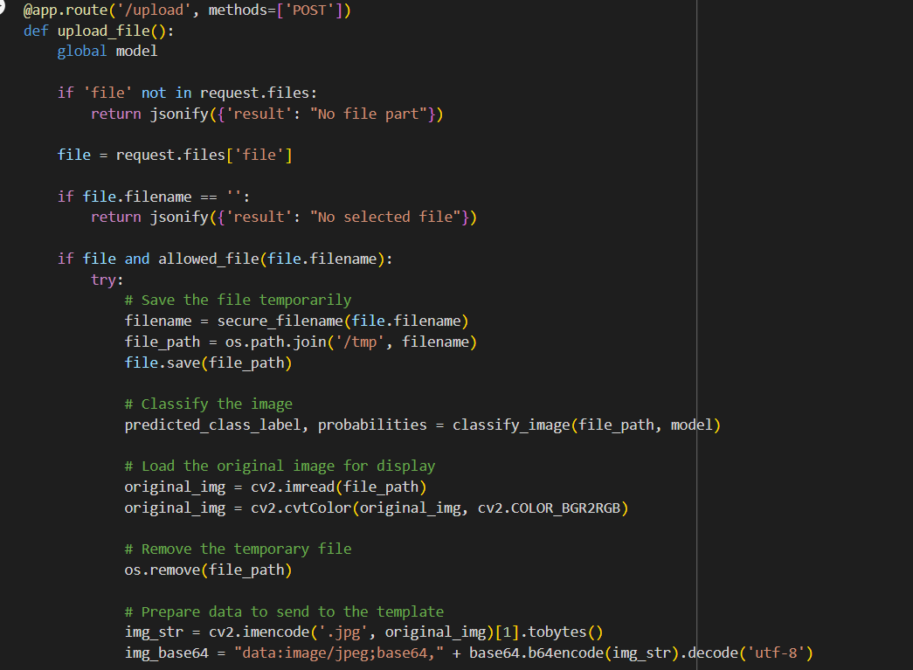

Fig 7.9 represents the Backend part of website

**Website received from ngrok**:

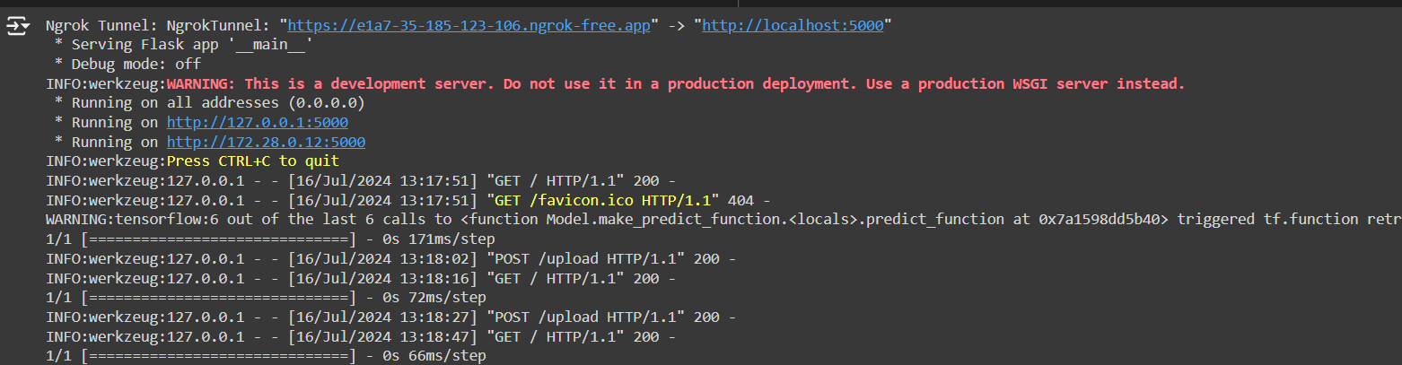

Fig 7.10 represents the website received from ngrok

**Data Visualization and Integration:**

* Data Visualization: Create visual representations of model performance and data insights using tools like Matplotlib, Seaborn, or Plotly. Include visualizations such as accuracy plots, confusion matrices, and loss curves.
* Integration into Application: Embed visualization components into your web or mobile application to display real-time insights and analytics. Ensure the visualizations are user-friendly and provide valuable information to users.
* Data Integration: Connect and integrate data from various sources into your application and model. Develop data pipelines for smooth data handling and ensure that your application can process and update data in real-time.

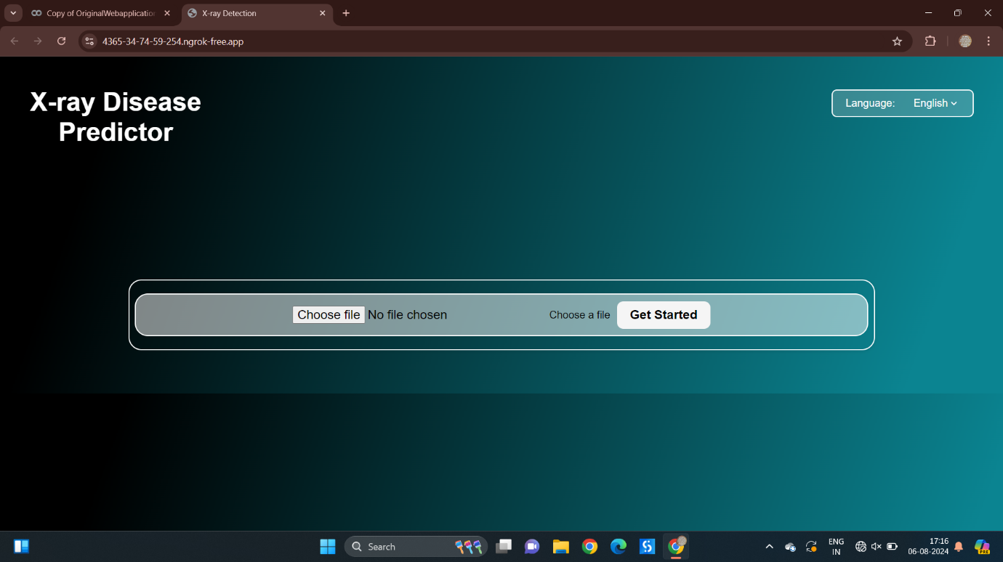

Fig 7.11 represents the web interface of X-ray Disease Predicator

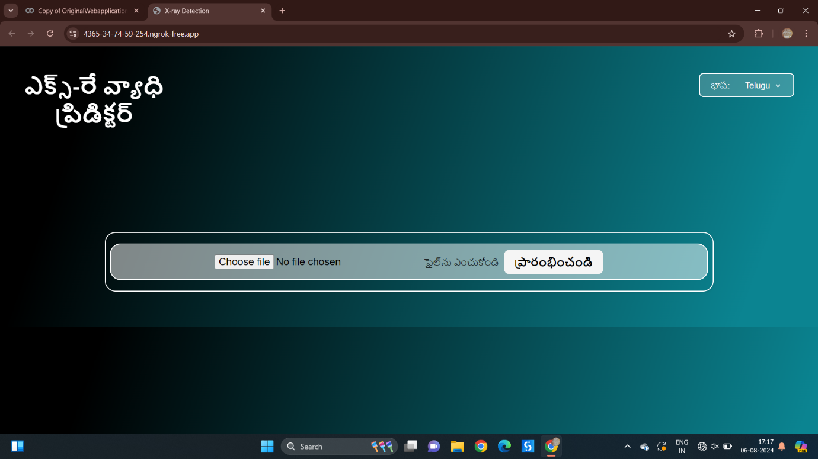

Fig 7.12 represents that the website is in three languages(English,Hindi,Telugu)

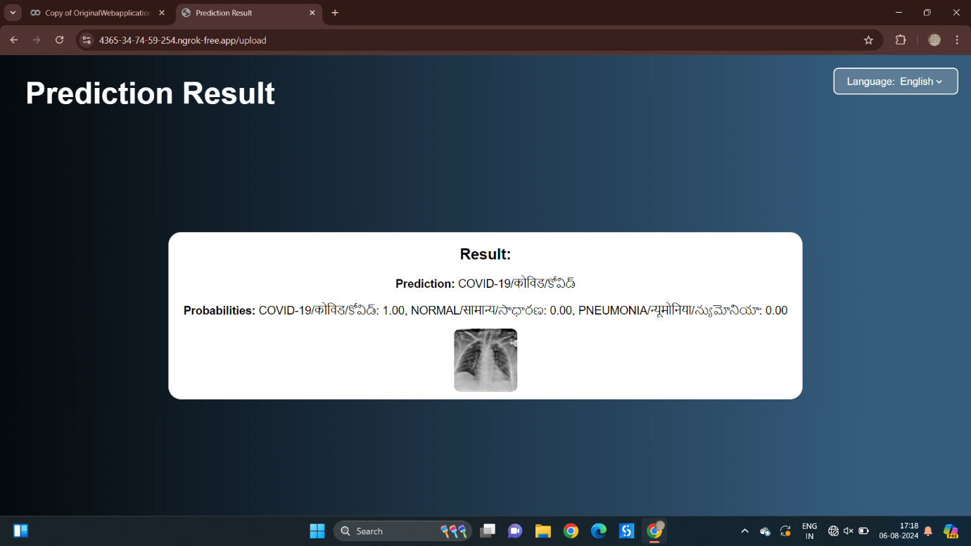

Fig 7.13 represents the Prediction result of Covid X-ray Image

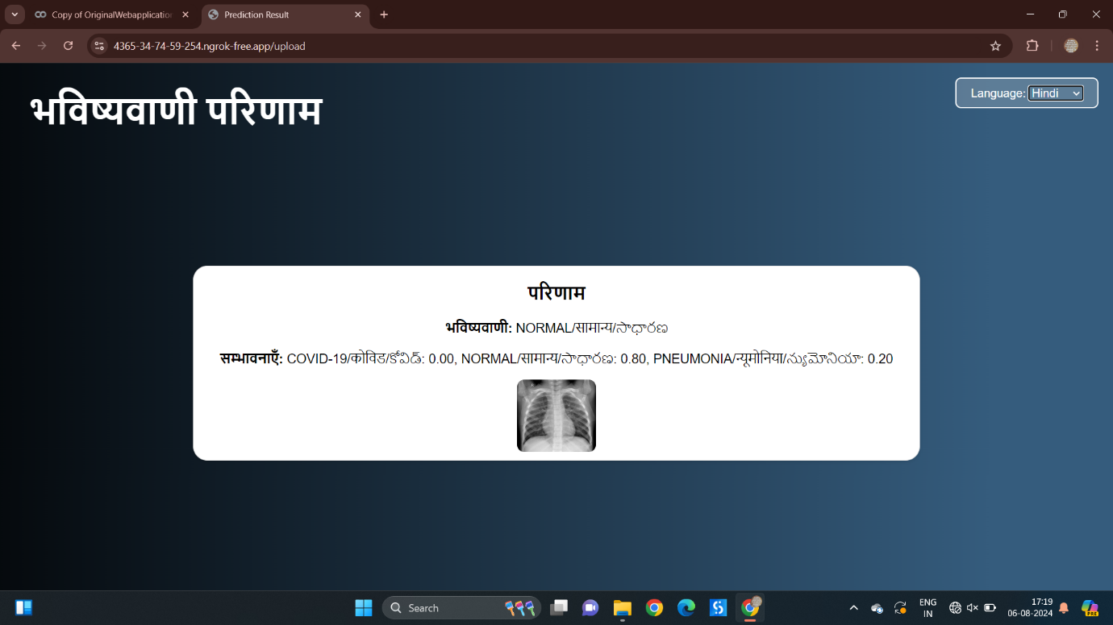

Fig 7.14 represents the Prediction result of Normal X-ray Image

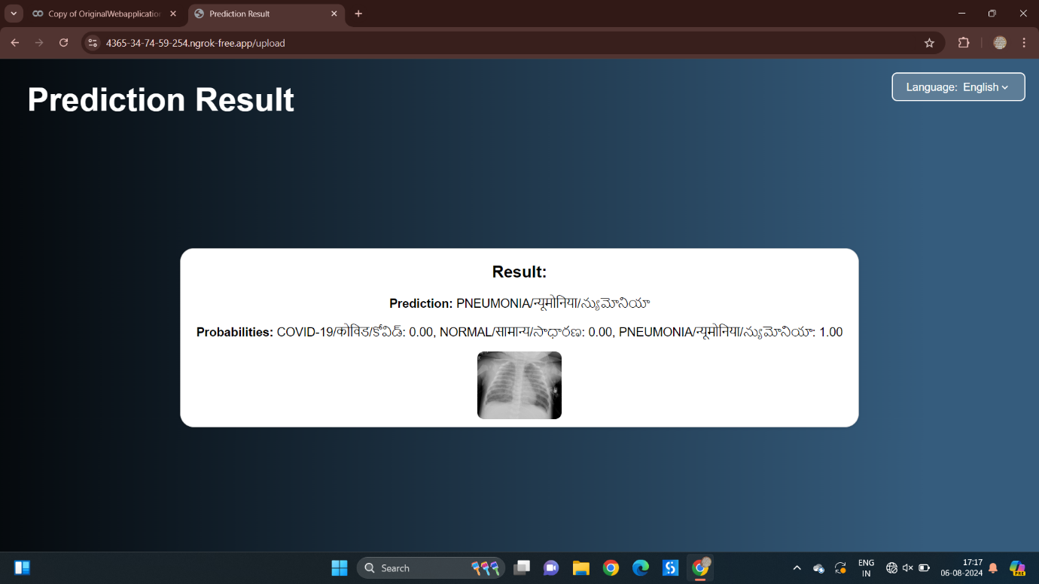

Fig 7.15 represents the Prediction result of Pneumonia X-ray Image

**FLOW CHART**

Continue………

**CONCLUSION**

Throughout the internship, it’s a transformative learning experience, immersing myself in the intricacies of machine learning with TensorFlow. Beginning with the fundamentals of neural networks, I gained a comprehensive understanding of model architecture, parameter tuning, and the training process. This foundational knowledge laid the groundwork for my exploration into more specialized areas of machine learning.

In summary, the Internship experience has been an enriching journey through various facets of machine learning, leveraging the powerful capabilities of TensorFlow. Beginning with foundational concepts in neural networks, I acquired essential skills in model construction, training, and evaluation. Exploring advanced techniques in subsequent chapters further deepened my understanding of machine learning methodologies. From optimizing model performance to enhancing scalability, each chapter provided invaluable insights into the complexities of real-world applications.

Overall, this internship has equipped me with a diverse skill set and a profound appreciation for the potential of machine learning in addressing complex problems. As I transition to the next phase of my career, I am confident that the knowledge and experiences gained during this internship will serve as a solid foundation for future endeavors in the dynamic field of machine learning.

**PREFERENCES**

1. <https://www.geeksforgeeks.org/image-classifier-using-cnn/>
2. <https://www.analyticsvidhya.com/blog/2021/01/image-classification-using-convolutional-neural-networks-a-step-by-step-guide/>
3. <https://www.tensorflow.org/lite/examples/image_classification/overview>
4. <https://www.youtube.com/watch?v=qm56XcRBXWc>
5. <https://www.kaggle.com/datasets/prashant268/chest-xray-covid19-pneumonia/data>
6. <https://www.geeksforgeeks.org/convolutional-neural-network-cnn-in-machine-learning/>
7. <https://buffml.com/multi-class-image-classification-flask-app-complete-project/>
8. <https://www.youtube.com/watch?v=ksCYBZIGShI>
9. <https://levelup.gitconnected.com/implementing-custom-deep-learning-model-into-flask-app-for-image-recognition-3ccd4e451839>
10. <https://github.com/MechMaster95/X-ray-Image-Classification>
11. <https://www.tensorflow.org/>
12. <https://developers.google.com/learn/pathways/tensorflow#codelab-https://developers.google.com/codelabs/tensorflow-2-computervision>
13. <https://developers.google.com/codelabs/tensorflow-3-convolutions?continue=https%3A%2F%2Fdevelopers.google.com%2Flearn%2Fpathways%2Ftensorflow%23codelab-https%3A%2F%2Fdevelopers.google.com%2Fcodelabs%2Ftensorflow-3-convolutions#1>